**NIST COLLEGE**

Affiliated toTribhuvan University



Project report of Web Technology

Topic: Apartment rental website

Submitted To:

Sanjog Sigdel

Nist College

Submitted By:

Anjana Khatri

Bishal Raut

Bimesh Shrestha

CSIT 5th sem

Submission Date:

Introduction

Topic of our project is apartment rental website. The name of our website is "HOME FOR ALL" with slogan "*We'll help you find your new home"*.

Group members of our project are Anjana Khatri, Bishal Raut and Bimesh Shrestha.

Objective

The main objective of our project is:

* to help the renters to find their home and apartments
* to help the rentals to advertise their apartments and homes for rents
* People can easily find best apartments and home at affordable rents with best facilities and good security through our website.

Overview

As we already mentioned above this project is about apartment rental website, we help people search apartments and also advertise about their apartments and home for rents.

We have included home page containing navigation bar, search bar and so on. Through navigation bar we can visit to others pages like landlord, customer care, listings, log in and signup pages. Here people can search apartments at appropriate location with desired facility and features. Rental can advertise through our website fulfilling basic requirements for advertisements with their basic info. Frontend of our website looks like below:

Home page:

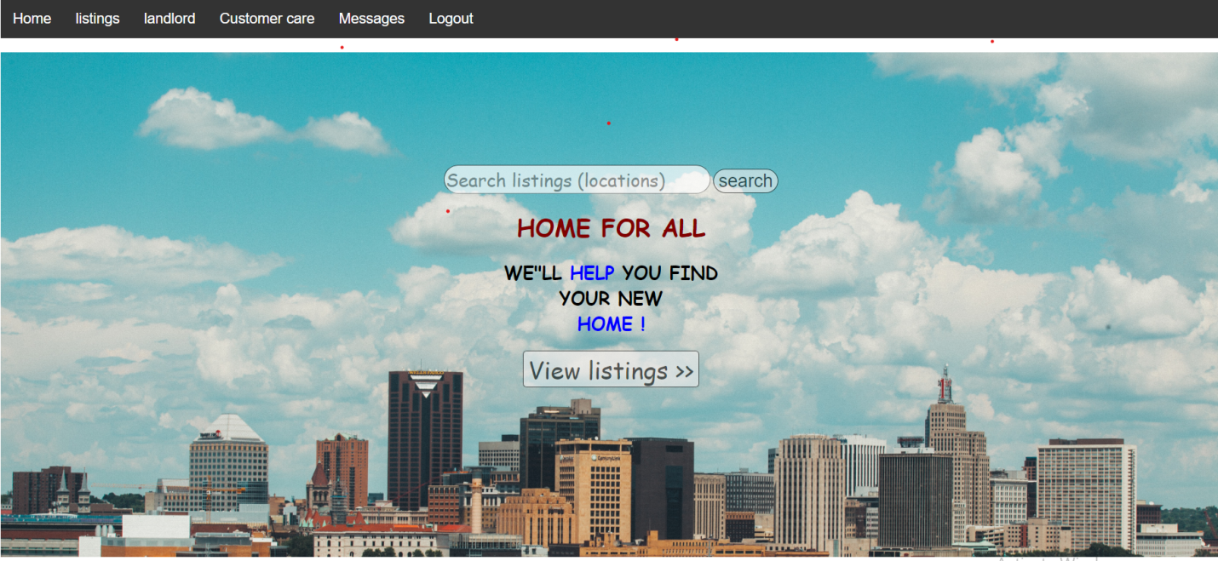

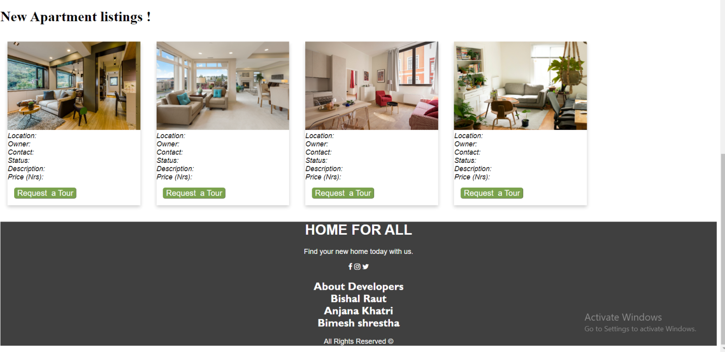

Landlord page:

This page contains the information about landlord and status of apartment, cost, location and general description of apartment. 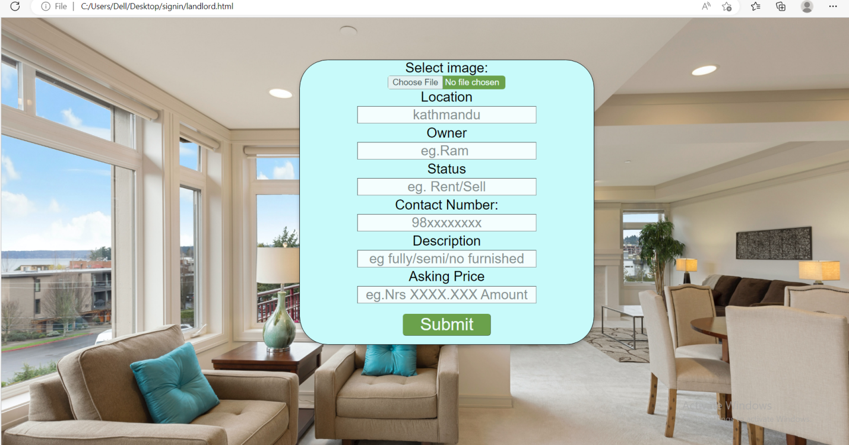

Listings:

This page contains all the available general information about apartments and homes in our websites. Renter can request home tour through this page.

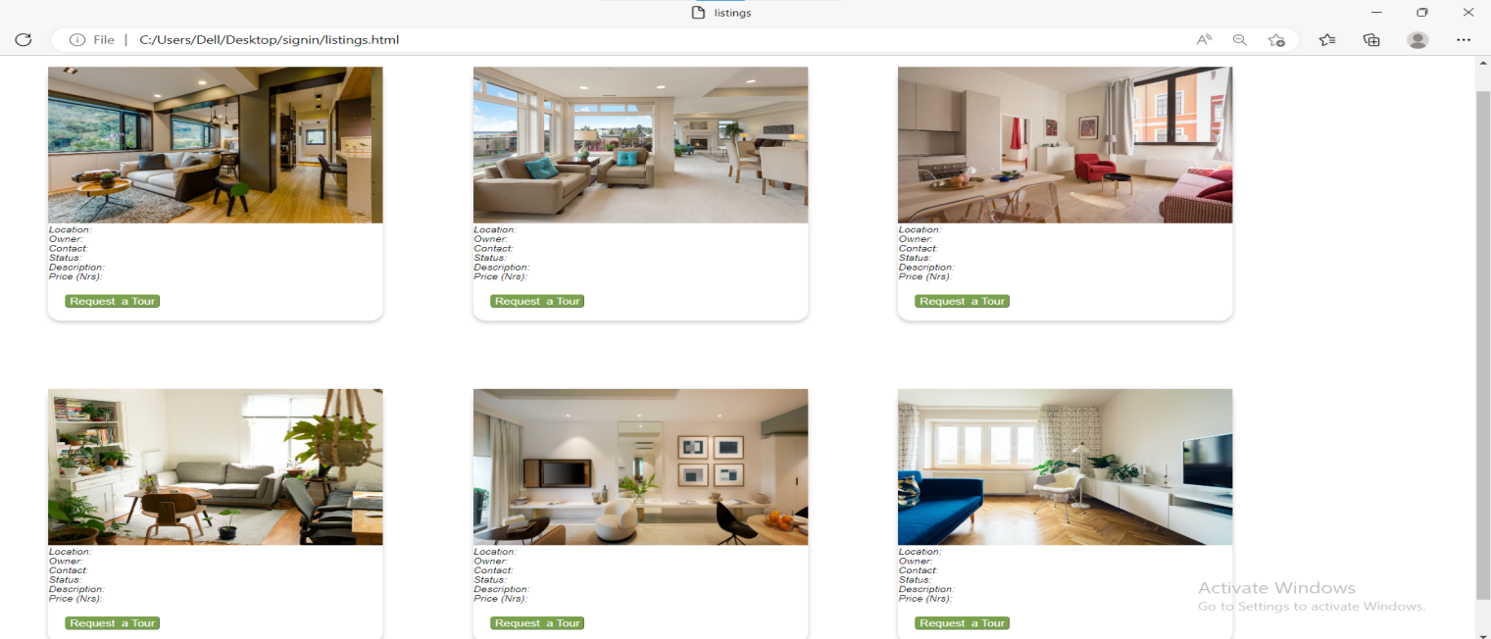Login and signup page:

Through this page people can login to our website if they already have account. If you don’t have account you can sign up using signup page.

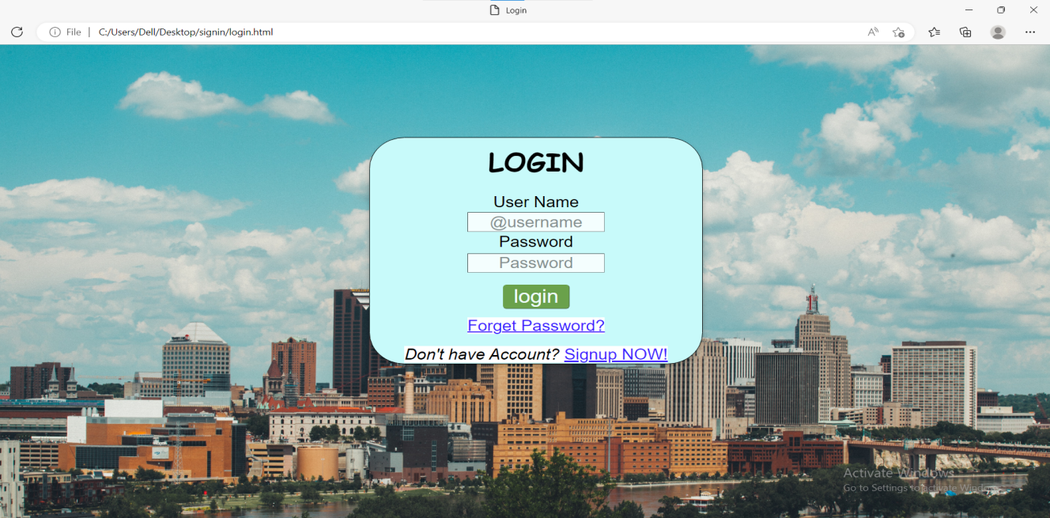

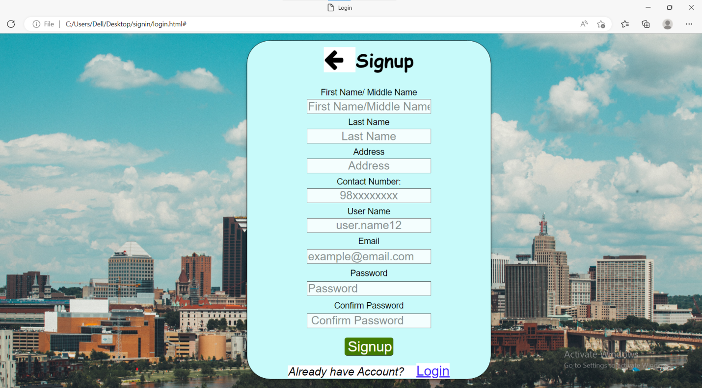

Dashboard:

A website dashboard is an online report where your website data from ecommerce to web analytics is displayed.

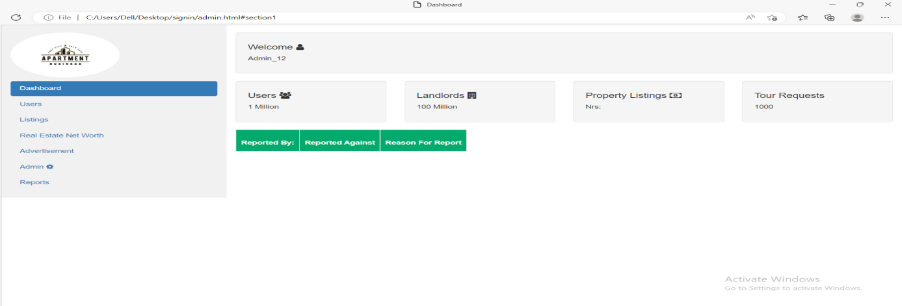

How is website made?

We have prepared this website using html, css and bootstraps.

HTML(Hyper Text Markup Language):

It is the standard markup language for documents designed to be displayed in a web browser. It can be assisted by technologies such as cascading style sheets (CSS) and scripting languages such as JavaScript.

Various html tags and elements are used in designing the web pages. Most common html tags used are:

* <html>:Root element of html page.
* <head>:contains meta information about the html page
* <title>:specifies a title for the html page.
* <body>defines document's body and is a container for all the visible contents,such as heading, paragraphs, images, hyperlinks, tables, lists, etc.
* <h1>: defines large heading
* <p>: defines a paragraph
* <a>:defines html links, href attribute is used to specify link's destination.
* <img>: defines html images
* style: attribute used to set the style of html elements
* <table>: defines a table
* <th>:defines header cell in a table
* <td>: defines cells in table
* <form>: used to create an html form for user input
* <input>:form element used in html
* type: attributes defines the type of input
* <label>: defines a label for many form elements
* class: attributes used to point a class name in a style sheet. It can be used by multiple HTML elements
* id: attributes that specifies a unique id for an HTML elements
* <nav>: defines a set of navigation links